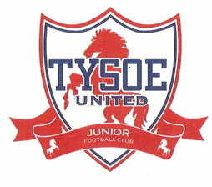

Tysoe United Junior Football Club – Club Complaints Procedure
In the event that any member feels that he or she has suffered discrimination in any way or that the Club Policies, Rules, or Codes of Conduct has been broken they should follow the procedures below:
1. They should report the matter to the Club Chairman or Club Welfare Officer or another member of the Committee.
Your report should include:
- Details of what, when, and where the occurrence took place
- Any witness statement or names
- Names of any others who have been treated in a similar way
- Details of any former complaints made about the incident, date, when, and to whom made
- A preference for a solution to the incident
2. The Club’s Management Committee will sit for any hearings that are requested.
3. The Club’s Management Committee will have the power to:
- Warn as to future conduct
- Suspend from membership
- Remove from membership and person found to have broken the Club’s Policies or Codes of Conducts.

